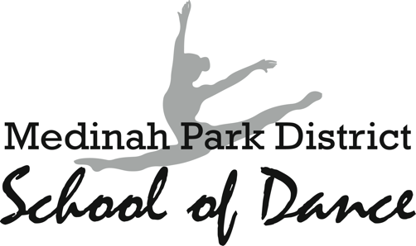

RECITAL T-SHIRTS ORDER FORM
Souvenir T-shirts $12 each. For an extra $5 you can get the following places on the back of the shirt: “DANCE DAD”, “DANCE MOM”, “DANCER”, “DANCE BRO”, “DANCE SIS”, “YOUR FIRST NAME”. You can pre-order your t-shirt by filling out the below T-shirt Order Form and return it by Wednesday, May 1

Please list the number of t-shirts you want from each size. Then record your total and attach payment. All payments must be made up front. All checks can be made out to “Innovation Arts Connection”.

DANCER’S NAME: ________________________________________________

PARENT’S NAME:_________________________________________________

PARENT’S PHONE NUMBER:_______________________________________

SIZE | AMOUNT | OPTIONAL: NAME ON BACK  ***Extra $5, See options above. |  | TOTAL
CS
CM
CL
CXL
AS
AM
AL
AXL
A2XL
A3XL
A4XL
 |  |  | GRAND TOTAL:

Circle one:

CHECK CASH

PLEASE RETURN TO MISS LORA.

QUESTIONS? EMAIL: lora@innovationartsconnection.com

